PROJECT: CART VALUE AND BUSINESS DEVELOPMENT ANALYSIS
By Phu Vinh Nguyen

I - Project Overview:
A food company wants to produce the highest profit for the next marketing campaign, scheduled for the next month. A pilot campaign involving 2205 customers was carried out, customers who bought the offer were properly labeled

I.I - Goals of the project 🎯
Business Goal:
- Increase the business profits by targeting features that help increase shopping cart value of an individual.
Questions to answer:
- Which model is the best to explain the whole picture of the business?
- Determine which elements contribute to a customer’s cart value significantly?
- How important are those features? Statistical evidence?
- Which insights and solutions can be drawn from the analysis?

I.II - Data sources 🗂️
Name: Marketing Analytics
Link: https://www.kaggle.com/datasets/jackdaoud/marketing-data/data
The data set ifood_df.csv consists of 2205 customers of XYZ company with data on:
- Customer profiles
- Product preferences
- Campaign successes/failures
- Channel performance

I.III - Data overview 🔍
- The datasets has 2205 rows and 39 columns with usability score of 9.41

*The only partial dictionary of each variable found in ifood_df.csv

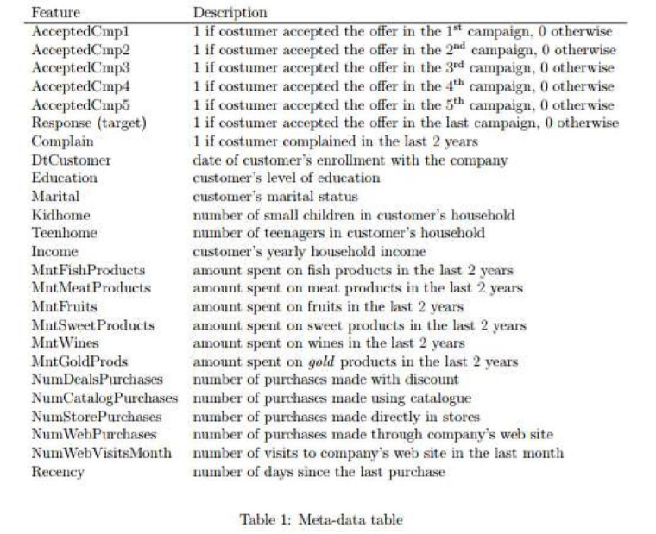

II - Overall Plan:

II.I - Data Cleaning 🛠️
- Clean all the missing values, duplicates
- Convert the data types
- Handle outliers
- Rename the columns
*Analytical Tools: Python

II.III - Exploratory Data Analysis (EDA) 👨‍💻
- Overview columns and summarize statistics for all variables
- See which categories contribute to the cart value the most
- Unveil visualizations to uncover patterns and relationships
*Analytical Tools: Python

II.II - Analysis 🧮
- Testing Regression Model
- Build hypotheses to see which traits influence customer spending behaviors
*Analytical Tools: Python

II.IV - Visualization 📊
- Build charts, dashboards on Power BI
- Python visualization libraries

II.V - Data Storytelling 💬
- Structure the script (Headlines, ideas) on PowerPoint/ Canva
- Make sense of all the numbers by facts and insights for better decision-making in the business.

II.VI - Insights and Recommendations 💡
- Presenting findings and initiatives on PowerPoint/ Canva
- Build up strategies for business based on concrete evidence found during analysis.

III - Deliverables:
- Slides presentation: storytelling + visual + insight
- Code and Documentation: Github: README.md, All code files
- Final Report: project’s purpose, methodologies, findings, and recommendations.

